Scoping and Forming Research Questions
We formulated a central research question and hypothesis based on the extant literature documenting the demographic shifts and characteristics of new and beginning farmers and statistical data from the 2017 Census of Agriculture (Census of Agriculture, 2019).
R.Q.: What are the motivations, goals, and identities of new and beginning organic farmers?
Hypothesis: New and beginning organic farmers will be motivated by environmental and social justice goals that develop multiple and conflicting identities.
We conducted a preliminary search for journal articles addressing “beginning farmers” in summer 2019. We searched seven databases, including Academic Search Premier, Web of Science, Social Science Research Network, ProQuest Social Science Database, PsychNet, PubMed, and PubAg. This initial search yielded 2,458 records. We reviewed articles based on their title and eliminated irrelevant topics, which resulted in 476 records. Next, we reviewed article abstracts to eliminate articles that did not include our sample population, new and beginning farmers. We concluded this search with 135 records relating to our research question. We extracted the keywords from these 135 articles and ranked the keywords based on frequency.
Next, we convened a panel of experts to review the keywords. The purpose of an expert review is to collaborate with stakeholders who have different expertise in a given field of study. Researchers can obtain scientific data while stakeholders can help interpret it, clarify, offer direction, and point out inconsistencies or areas that need clarification. We asked an expert panel to review the top 20 keywords we extracted from our search. Next, we asked them to select and rank the top 10 keywords they think would best answer our research question (see Table 1 for the final list of keywords). The expert review panel consisted of an organic farmer, a leader of the Florida Black Farmers and Agriculturalists Association, a program leader in the USDA’s small farm research and extension program development, a professor of agricultural economics, and a leader in our local Young Farmers & Ranchers chapter. This expert review was approved by the University of Florida’s Institutional Review Board (IRB protocol # 201901751).
Table 1. List of search terms
Topic search sequence | Boolean designation
“beginning farm*” | AND
“organic farm*” | OR
“young farm*” | OR
“local farm*” | OR
“new farm*” | OR
“farm succession” | OR
“sustainable farm*” | OR
“small and medium-sized farm*” | OR
“minority farm*” | OR
“women farm*” | OR
“urban farm*”
Planning
We prepared for our literature search by establishing explicit inclusion and exclusion criteria. We limited our search according to the type of scholarly record, database, geography, the language of records, years of publication, and must address at least one component of the research question. The inclusion criteria were: (a) published scholarly, peer-reviewed journals, (b) found using the Web of Science database, (c) published in the United States, (d) published in the English language, (e) published within the last ten years (2010-2020), and (f) the study subject addresses new and beginning farmers, organic farmers, or young farmers. Articles were excluded if any of these six components were not addressed in the abstract, results, or discussion sections of the study.
We chose to focus on articles that were published in scholarly peer-reviewed journals found in the Web of Science and Scopus databases published within the last ten years. This study is concerned with systematic, academic research about new and beginning organic farmers. A systematic literature review in part assesses the quality of available academic research (Siddaway et al., 2019). To control this parameter, we exclude “grey” literature, including government reports and theses and dissertations. We searched two databases, Web of Science and Scopus, because together they are comprehensive citation databases in the social science discipline and well-accepted as a useful bibliometric tool (Garcia et al., 2017; Sanchez et al., 2017; Wang & Waltman, 2016; ). We chose the 10-year parameter due to rapidly changing economic and social conditions that may shape farmer demographics and economic trends, such as the Great Recession. Articles published before 2010 may no longer be relevant to the current characteristics that shape socio-ecological models of farmers.
The initial search returned 223 records from WoS. We reviewed articles by title to eliminate irrelevant subjects (43 records remained). Next, we reviewed article abstracts to eliminate articles that did not address new and beginning farmers, organic farmers, or young farmers (25 records remained). We extracted relevant information from each article, including research design, research methods, number of participants and demographics, theoretical framework and constructs, results, area of study, and conclusions. We further refined our article list based on sample criteria and demographics, i.e., new and beginning, organic, or young. These two indicators helped us eliminate studies that did not include new and beginning organic farmers. Next, we conducted the same search on Scopus. The search returned 34 records. We eliminated irrelevant topics by title (29 records remained), and then by abstract (2 records remained). Of the remaining two, one record overlapped with the Web of Science search, and we added one record to this study.
Next, three authors in this study conducted a quality review to determine if the final 22 articles adequately meet the inclusion criteria. We assessed each article according to quality criteria established by Peach and Parris (2013). High-quality articles are clear, have relevant background information, have the appropriate design that corresponds to data collection methods and analysis techniques, identify theoretical perspective, detail participant recruitment, and context, procedural rigor in data collection and analysis, and results are comprehensive and well described (Parris & Peachy, 2013, p. 382). We concluded that study clarity, relevance, appropriateness, and rigor. We eliminated four articles from our study that we agreed were not high quality, did not fit this study’s aim, or had insufficient data to consider high quality. We eliminated two articles because they did not specify a sample of new and beginning or organic or young farmers, one because the results and discussion were not about farmer characteristics and one study for an insufficient sample size of one. Thus, the final sample of records used in this SLR totaled 22 peer-review journal articles.
We analyzed the selected articles using a social ecology approach, adapted from McLeroy et al. (1988). The SEM layers are intrapersonal, interpersonal, institutional, community, and policy (Figure 2). The multi-layered model captures the relationships between a person and the context of their experiences and the influence their experiences have on a specific outcome (Bronfenbrenner, 1989; McLeroy et al., 1988; Stokols, 1992; Stokols, 1996). In our analysis, we focused on characteristics that apply to farmers and starting a farm. Table 2 lists McLeroy et al.’s definitions of their ecological layers and examples of how we conceptualized these layers in a farming context. For instance, for the intrapersonal layer, we looked for farming knowledge and skills, identity, finances, and values. Interpersonal includes a farmer’s relationships with their families and social support network members. Institutional includes how the farmer runs their farm and interacts with employees. Community includes farmer organizations and educational opportunities. Policy includes those that impact farmers like organic certification, cottage laws, urban zoning, and land use policy. We adapted this framework to accommodate farming as the outcome. We report the results of our analysis in the following section.
Table 2. The socio-ecological model with McLeroy et al.’s definitions of five layers and the present study’ conceptualization
Socioecological Layer | Definition, McLeroy et al. (1988) | Conceptualization in the present study (examples)
Intrapersonal | Characteristics of the individual, such as knowledge, attitudes, behavior, self-concept, skills, and developmental history. | Farming experience, farming practices, identity (e.g., gender, religious, sexual), financial resources, values, goals, and expectations.
Interpersonal | Formal and informal social networks and social support systems, including family, work group, and friendship networks. | Family on-farm, workers who live on the farm, tradition.
Institutional | Social institutions with organizational characteristics and formal (and informal) rules and regulations for operations. | Farm operation including farm safety, training volunteers and interns, farm procedures, daily on-farm activities
Community | Relationships among organizations, institutions, and informational networks within defined boundaries. | Farmer organizations, co-ops, CSA, conferences, webinars, courses, farm tours, educational opportunities like workshops
Public Policy | Local, state, national, and global laws and policies. | USDA Organic Certification, Certified Natural Grown, land use policy (especially urban), food safety acts, Cottage Laws, grants, scholarships

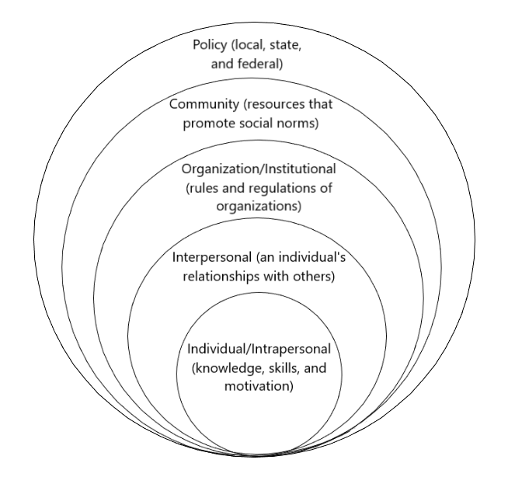

Figure 2. Socio-ecological model adapted from McLeroy et al., 1988.

